**PROJECT**

**2) Transformation Using Power Query**

**Data Cleaning:**

**Handling Missing Values and Duplicates:**

➢ Replace missing values (null) in the 'emp_length' column of the "BorrowerDetails" table with '0 year'.

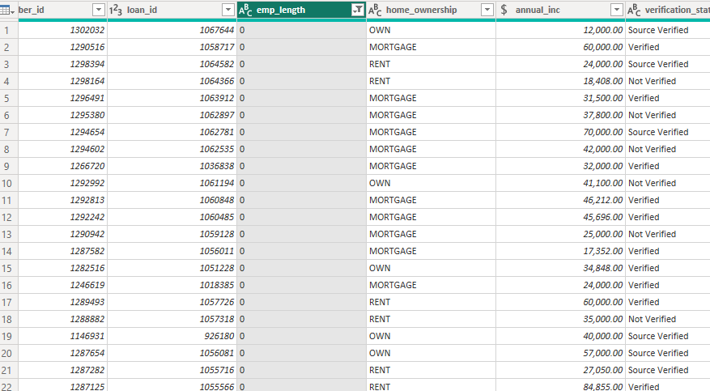

➢ Remove rows with missing values in the 'last_pymnt_d' and 'delinq_2yrs' columns.

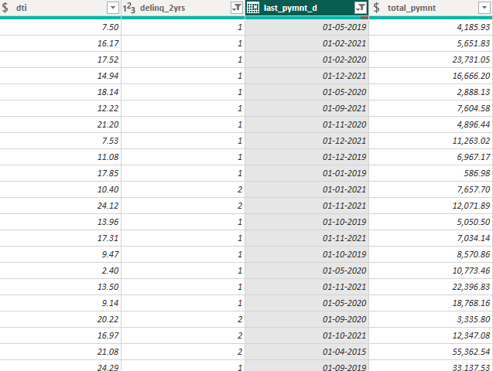

**➢ Remove duplicate rows in the 'id' column of the "LoanDetails" table.**

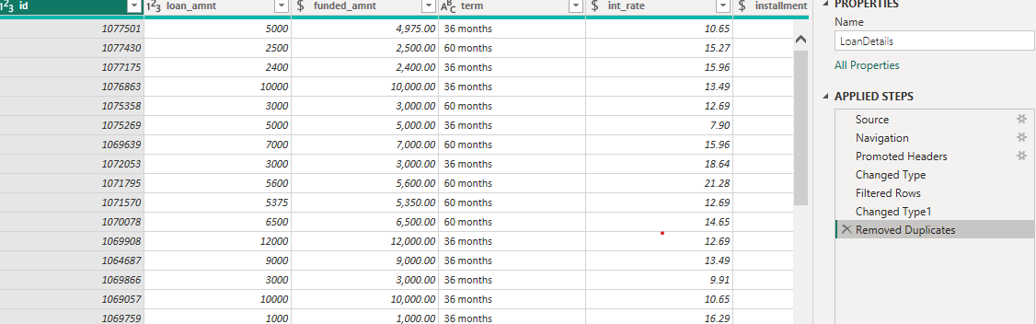

**Dealing with Inconsistencies:**

➢ Ensure words in the 'purpose' column are separated by spaces instead of

underscores (e.g., "credit card" instead of "credit_card").

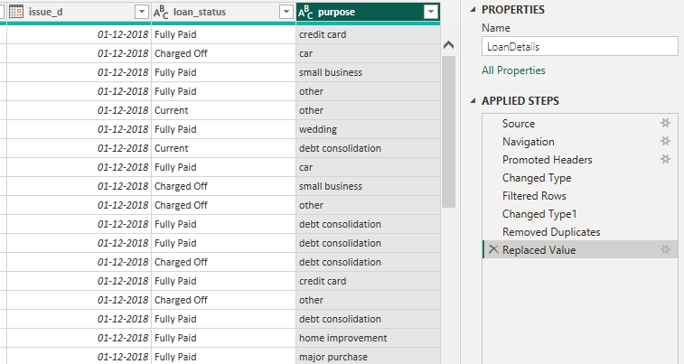

➢ Format the 'purpose' and 'home_ownership' columns to proper case.

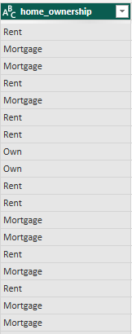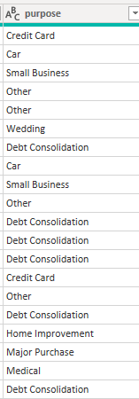

Data Transformation:

**Column Transformation:**

➢ Change the data type of the 'total_pymnt' column to 'Fixed decimal number'.

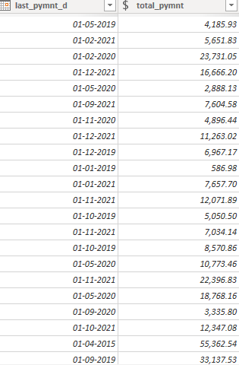

➢ Round off the numbers in the 'funded_amnt' column to 2 decimal places.

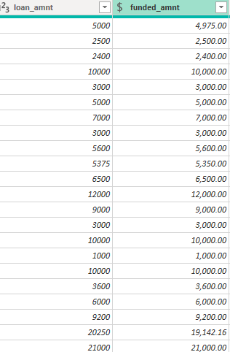

**Column Renaming:**

➢ Rename the column 'issue_d' to 'issue_date'.

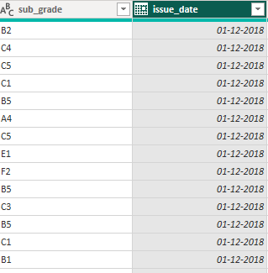

➢ Rename the column 'last_payment_d' to 'last_payment_date'.

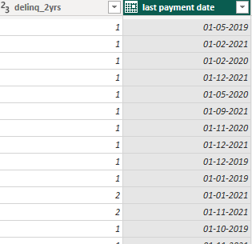

**Creating New Columns:**

➢ Create a new custom column named 'total_amount_paid' to calculate the total

amount paid by each borrower by subtracting 'out_prncp' from 'total_pymnt'.

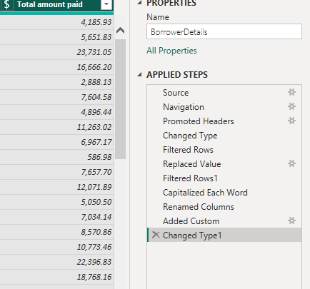

➢ Add a new conditional column named 'delinquency_status' to identify if the

borrower has any delinquencies. If the number of delinquencies in 'delinq_2yrs' is

greater than 0, the status should be "Delinquent", otherwise "Not Delinquent".

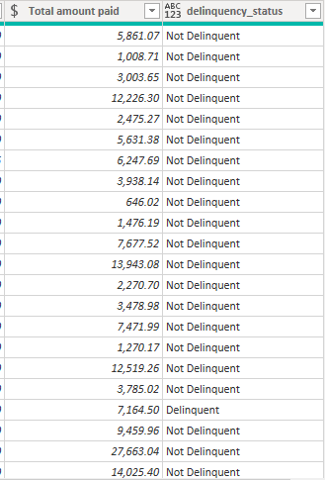

**Column Dropping:**

➢ Remove the 'sub_grade' column as that does not significantly contribute to the

analysis.

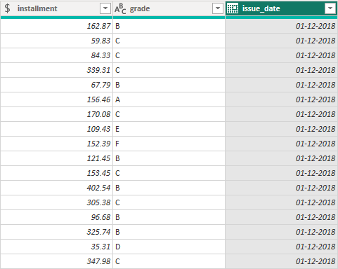

**REPORT 1**

**Loan Performance Analysis**

**The Loan Performance Analysis report aims to provide insights into the performance of**

**loans based on various factors such as loan amount, loan status, term, interest rate, and**

**purpose.**

**➢ Total Funded Amount: Create a card visual to display the total funded amount.**

**➢ Fully Paid Loan Percentage: Create a gauge chart to display the 'Fully Paid Loan**

**Percentage' measure.**

**➢ Average Interest Rate by Term: Create a multi-row card to show the average**

**interest rate for each term.**

**➢ Loan Status Distribution: Create a pie chart to visualize the sum of total**

**payments by loan status.**

**➢ Loan Amount by Purpose: Create a treemap to show the average loan amount by**

**purpose.**

**➢ Installment Over Time: Create a line chart to visualize the sum of installments by**

**Year and Quarter of the issue date.**

**➢ Maximum Total Amount Paid by Loan Status: Create a column chart to display**

**the maximum total amount paid by loan status.**

**➢ Minimum Annual Income by Grade: Create a funnel chart to show the minimum**

**annual income by grade.**

**➢ Issue Date Slicer: Add a slicer for the Month of the issue date to enable dynamic**

**data exploration.**

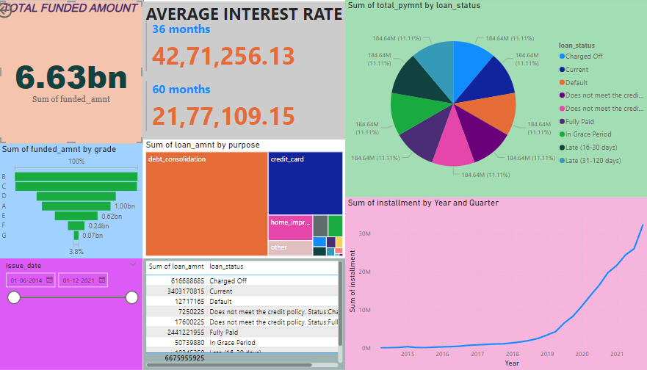

**REPORT 2**

**Borrower Profile Analysis**

**The Borrower Profile Analysis report aims to provide insights into the characteristics of**

**borrowers such as home ownership, annual income, employment length, verification**

**status, debt-to-income ratio, and delinquency history.**

**➢ KPI Visual: Create a KPI visual with the sum of total payment as the value, the**

**year of last payment date as the trend axis, and the sum of loan amount as the**

**target. Round off to 2 decimal points and format as $ currency.**

**➢ Average of Annual Income: Display the average of annual income using a card**

**visual.**

**➢ Non-Verified Borrowers Count: Display the count of non-verified borrowers using**

**a card visual.**

**➢ Average Debt-to-Income by Delinquency Status: Create a multi-row card to show**

**the average debt-to-income ratio by delinquency status.**

**➢ Sum of Loan Amount by Home Ownership: Create a table to show the total loan**

**amount by home ownership.**

**➢ Average Remaining Principal by Verification Status: Create a donut chart to**

**display the average remaining outstanding principal by verification status.**

**➢ Sum of Delinquencies by Home Ownership: Create a bar chart to show the total**

**number of delinquencies in the past 2 years by home ownership and filter the**

**visual to display only Mortgage, Rent, and Own.**

**➢ Max Remaining Installments by Employment Length: Create a treemap to show**

**the maximum remaining installments by employment length.**

**➢ Total Amount Paid and Funded Amount Over Time: Create a line chart to display**

**the sum of total amount paid and the sum of funded amount by the year of last**

**payment date.**

**➢ Purpose Slicer: Add a slicer for loan purpose to enable dynamic data exploration.**

